Purpose:
In this week's lab, you will create users and grant specific privileges to those users. You will also assign a default tablespace and create some tables in that tablespace owned by one of the new users. You will then create several new roles, grant privileges to the roles and then grant the roles to particular users based on the user's requirements for being able to update, select, or delete data in those tables.

Deliverable:
Complete this document, submit it via BrightSpace, and (if asked) demonstrate the results to the lab professor. This lab is worth 2 marks towards the lab/assignments component of your final grade.

Requirements:
- Predefined Privileges: Oracle classifies SYSTEM privileges as actions that apply to the system or types of objects. For example, CREATE DATABASE, CREATE TABLESPACE, and CREATE TABLE. The entire set of system and object privileges are listed and described in the documentation available at:
Privileges (oracle.com)
You will need to scroll down to see the long list of system privileges and could then navigate to each of their descriptions.

- The GRANT syntax is described at:
GRANT (oracle.com)
Oracle classifies OBJECT privileges as actions that apply to a particular object. For example, SELECT, INSERT, UPDATE, and DELETE actions on a specific table. Additionally, the owner of an object – say I created a table named Test - would automatically have SELECT, INSERT, UPDATE, etc. rights on Test. A user can also be granted rights on an object owned by another user – we will do this later in the current lab.
- Start SQLPLus and logon as SYS AS SYSDBA.
  - How many predefined system privileges are listed in the system_privilege_map view: 257

  - How many predefined object privileges are listed in the dba_tab_privs view: 14 (Hint: You won't want to SELECT * FROM dba_tab_privs as a large number of rows will be returned. Instead use an aggregation function to determine the number of rows in the view).

- Use the DBA_PROFILES table to list the details of the ‘DEFAULT’ profile.
Provide a screen shot below:
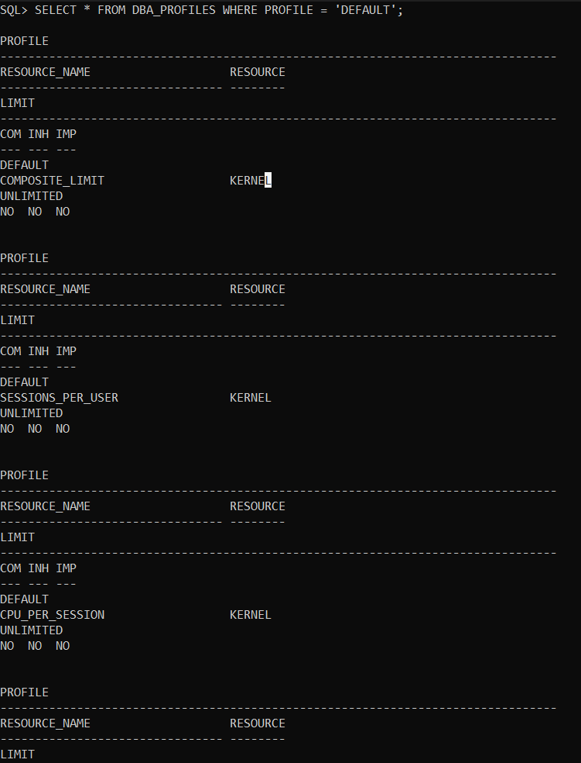
List 2 aspects of the default profile that could lead to performance issues: Allowing the user to have too many open sessions at once.
Allowing the user to have too many privileges to access the system.
List 1 aspect of the default profile that could lead to security issues: Not limiting the amount of failed logon attempts.

- In a sequence of “create user ….”, “alter user …” and other privilege granting steps, you are to create a new user with the following criteria:
  - Username - your last name (e.g., king)
  - Password – your last name (e.g., kingpwd)
  - Set the password to be expired. (It will need to be changed on next connection.)
  - Use the DEFAULT profile.
  - Use the default tablespaces (i.e., USERS and TEMP).
  - Use the “GRANT …. TO ….” command multiple times to grant CONNECT, RESOURCE and CREATE VIEW to the new user.
Show your work below:
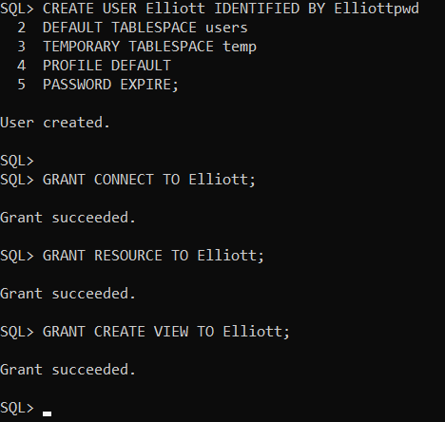
  - Keep your SQLPLUS session running as SYS AS DBA, and open a new command window (not as administrator). Then, logon to SQLPlus with your new account in the new window. You should get an 'expired password' message. When prompted enter lastnamepwd as your “New” password. (It will let you reuse the original one….)
  - Try to create a simple empty table from your new account. If successful, try to insert one record. What occurs? Show your work
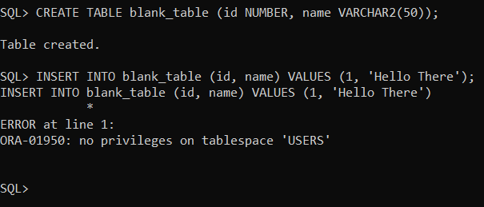
  - Keep your new account window open but change focus back to your original SYS as SYSBA window to alter the quota on the ‘USERS’ tablespace for your new user to be UNLIMITED.
e.g., “ALTER USER myname QUOTA UNLIMITED ON USERS;” Show your work here:
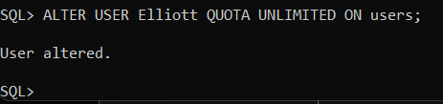

  - Return to your new account in the other window and retry creating a new table and inserting a single row. Show your work here:
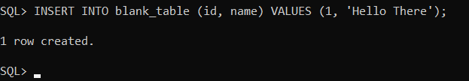

- Creating Roles: The information on the next page describes privileges that certain users have on specific tables. Technically, we could grant the correct object privilege on each table on a user-by-user basis … but that approach is inelegant, inefficient and scales poorly – what is feasible for the first 6 users is terribly problematic for the next 30,000. A more realistic (simplified) example would be BrightSpace – it has an ever-increasing number of users assigned to the student role and approximately 1,000 users assigned to the instructor role – with each role having different privileges.

Object Privileges | Tables (Objects)
 | AUTHORS | AUTHOR_TITLES | TITLES | PUBLISHERS
SELECT | UserA, UserB,  UserC, UserD,  UserE | UserA, UserB,  UserC, UserD,  UserE | UserA, UserB, UserC, UserD,  UserE, UserF | UserA, UserB,  UserC, UserD,  UserE
INSERT | UserA, UserB, | UserC, UserD,  UserE | UserF | UserC, UserD,  UserE
UPDATE | UserA, UserB, | UserC, UserD,  UserE | UserF | UserC, UserD,  UserE
DELETE | UserA, UserB, | UserC, UserD,  UserE | UserF | UserC, UserD,  UserE

  - Take the data from the table above and re-organize it in the format below. I have done the first row for you. Doing this will help you spot the privileges/object pairings for each user more easily. (Note: S=Select, I=Insert, U=Update, and D=Delete).
 | Authors |  |  |  | Author_Titles |  |  |  | Titles |  |  |  | Publishers
 | S | I | U | D | S | I | U | D | S | I | U | D | S | I | U | D
UserA | Y | Y | Y | Y | Y | N | N | N | Y | N | N | N | Y | N | N | N
UserB | Y | Y | Y | Y | Y | N | N | N | Y | N | N | N | Y | N | N | N
UserC | Y | N | N | N | Y | Y | Y | Y | Y | N | N | N | Y | Y | Y | Y
UserD | Y | N | N | N | Y | Y | Y | Y | Y | N | N | N | Y | Y | Y | Y
UserE | Y | N | N | N | Y | Y | Y | Y | Y | N | N | N | Y | Y | Y | Y
UserF | N | N | N | N | N | N | N | N | Y | Y | Y | Y | N | N | N | N

  - What is the minimum number of roles (i.e., grouping by common requirements) required to assign the correct privileges to the appropriate users? 3.

  - List the roles (e.g., role1, role2, etc.) and the users that should be assigned to each role.
Role 1: Assigned to UserA, UserB
Role 2: Assigned to UserC, UserD, UserE
Role 3: Assigned to UserF

Role 1 for all CRUD operations for Authors
Role 2 for all CRUD operations for Author Titles and Publishers
Role 3 for all CRUD operations for Titles

- Use the template below to create 6 users named UserA, UserB, UserC, UserD, UserE and UserF, and to grant them connect privileges.
CREATE USER UserF IDENTIFIED BY userfpswd
DEFAULT TABLESPACE users
TEMPORARY TABLESPACE temp
QUOTA UNLIMITED ON users;

Grant connect to userf;

Can these users create a table? No Why? They only have permission to Connect at this time. To create tablespaces, the user also must be granted “Create Table” permissions.

- Logon to your general user account (e.g., king). Use the SQL scripts posted in Brightspace create the Authors, Author_Titles, Titles, and Publishers tables. Then, use the posted insert file to add data to the tables. Document your work below.
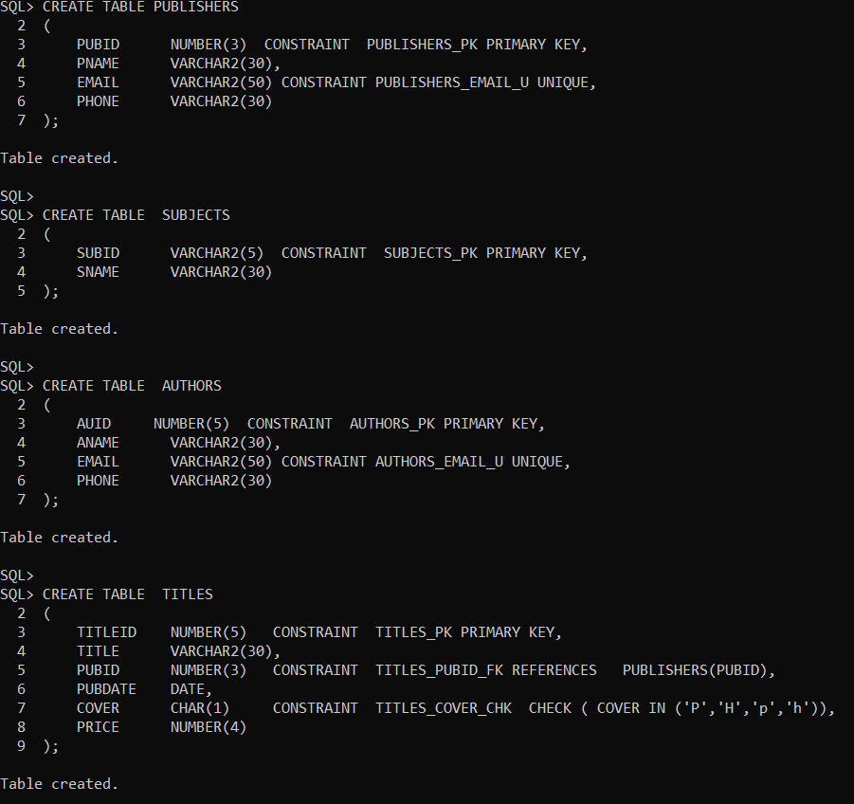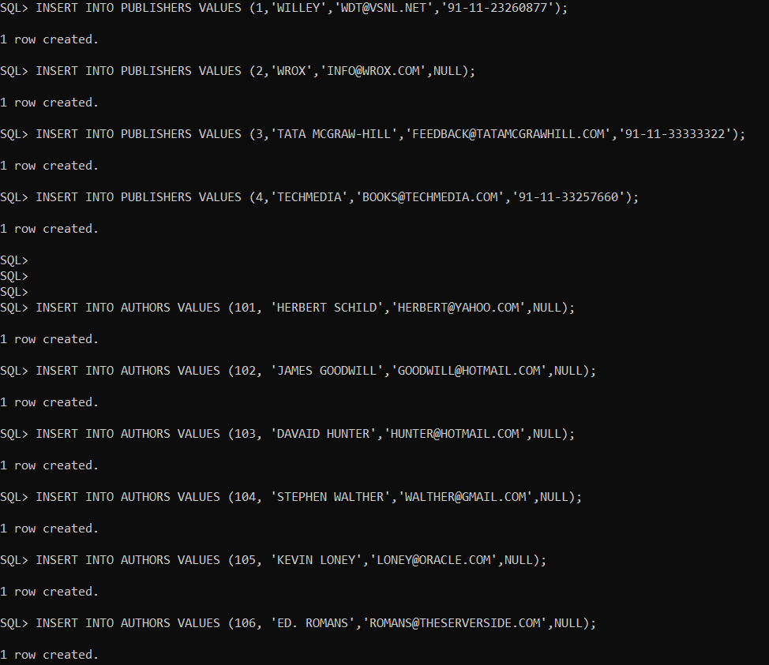

- Logon as SYS AS SYSDBA and enter: CREATE ROLE RoleElliott1; (for example, Roleking1). Create the number of roles you determined were needed in Question 2a above. Additional information on creating roles can be found here: http://docs.oracle.com/database/121/SQLRF/statements_6014.htm#SQLRF01311
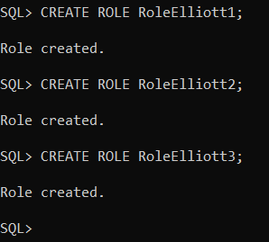

- Review the basic syntax for GRANTING an object privilege (e.g., SELECT, etc.) on a schema object (e.g., king.authors) to a role (e.g., Roleking1). Read the Restriction on Object Privileges sentence under the Grant_Object_Privileges clause description as it contains important information regarding whether, for example, you can grant a select on king.authors and select on king.titles in the same grant statement. Granting these two privileges in two separate grant statements is fine. http://docs.oracle.com/database/121/SQLRF/statements_9014.htm
Copy your GRANTs here:
GRANT SELECT, INSERT, UPDATE, DELETE ON Elliott.Authors TO RoleElliott1;
GRANT SELECT ON Elliott.Author_Titles TO RoleElliott1;
GRANT SELECT ON Elliott.Titles TO RoleElliott1;
GRANT SELECT ON Elliott.Publishers TO RoleElliott1;

GRANT RoleElliott1 TO UserA;
GRANT RoleElliott1 TO UserB;

GRANT SELECT ON Elliott.Authors TO RoleElliott2;
GRANT SELECT, INSERT, UPDATE, DELETE ON Elliott.Author_Titles TO RoleElliott2;
GRANT SELECT, INSERT, UPDATE, DELETE ON Elliott.Publishers TO RoleElliott2;

GRANT RoleElliott2 TO UserC;
GRANT RoleElliott2 TO UserD;
GRANT RoleElliott2 TO UserE;

GRANT SELECT, INSERT, UPDATE, DELETE ON Elliott.Titles TO RoleElliott3;

GRANT RoleElliott3 TO UserF;

  - Enter: DESC role_tab_privs for a description of the structure of the view that contains information about roles and their privileges. You may notice the first 5 columns are unnecessarily wide for our data. Use the COLUMN / FORMAT command to modify the displayed column width. Use this example as a guide:
SQL> column role format a10

Write a SQL query that selects all columns from the role_tab_privs view for all of your newly created roles and orders the results by role, table_name, and privilege. Paste the command and results here:
SELECT * FROM ROLE_TAB_PRIVS
WHERE ROLE IN ('ROLEELLIOTT1', 'ROLEELLIOTT2', 'ROLEELLIOTT3')
ORDER BY ROLE, TABLE_NAME, PRIVILEGE;

- Our next step is to grant the appropriate role or roles to the correct user(s).
Granting a role to a user is very similar to granting a privilege to a role or, for that matter, granting a role to another role. Use 'g' above as a model for granting a role to a user. Paste the commands and results here:
GRANT ROLEELLIOTT1 TO Elliott;

Additional detailed information is available in the GRANT section of the SQL Reference Guide http://docs.oracle.com/database/121/SQLRF/statements_9014.htm

  - After all of the role granting to users has completed, enter the following command and then paste the query and results in the space provided below:
select *
from role_tab_privs
where role like 'ROLE%'
order by role, table_name, privilege;
Paste the query and results here:
ROLE OWNER
------------------------------ ------------------------------
TABLE_NAME COLUMN_NAM PRIVILEGE
------------------------------ ---------- ------------------------------
GRANTABLE COMMON INHERITED
---------- ---------- ----------
ROLEELLIOTT1 ELLIOTT
AUTHORS DELETE
NO NO NO

ROLEELLIOTT1 ELLIOTT
AUTHORS INSERT
NO NO NO

ROLE OWNER
------------------------------ ------------------------------
TABLE_NAME COLUMN_NAM PRIVILEGE
------------------------------ ---------- ------------------------------
GRANTABLE COMMON INHERITED
---------- ---------- ----------

ROLEELLIOTT1 ELLIOTT
AUTHORS SELECT
NO NO NO

ROLEELLIOTT1 ELLIOTT
AUTHORS UPDATE

ROLE OWNER
------------------------------ ------------------------------
TABLE_NAME COLUMN_NAM PRIVILEGE
------------------------------ ---------- ------------------------------
GRANTABLE COMMON INHERITED
---------- ---------- ----------
NO NO NO

ROLEELLIOTT1 ELLIOTT
AUTHOR_TITLES SELECT
NO NO NO

ROLEELLIOTT1 ELLIOTT

ROLE OWNER
------------------------------ ------------------------------
TABLE_NAME COLUMN_NAM PRIVILEGE
------------------------------ ---------- ------------------------------
GRANTABLE COMMON INHERITED
---------- ---------- ----------
PUBLISHERS SELECT
NO NO NO

ROLEELLIOTT1 ELLIOTT
TITLES SELECT
NO NO NO

ROLE OWNER
------------------------------ ------------------------------
TABLE_NAME COLUMN_NAM PRIVILEGE
------------------------------ ---------- ------------------------------
GRANTABLE COMMON INHERITED
---------- ---------- ----------
ROLEELLIOTT2 ELLIOTT
AUTHORS SELECT
NO NO NO

ROLEELLIOTT2 ELLIOTT
AUTHOR_TITLES DELETE
NO NO NO

ROLE OWNER
------------------------------ ------------------------------
TABLE_NAME COLUMN_NAM PRIVILEGE
------------------------------ ---------- ------------------------------
GRANTABLE COMMON INHERITED
---------- ---------- ----------

ROLEELLIOTT2 ELLIOTT
AUTHOR_TITLES INSERT
NO NO NO

ROLEELLIOTT2 ELLIOTT
AUTHOR_TITLES SELECT

ROLE OWNER
------------------------------ ------------------------------
TABLE_NAME COLUMN_NAM PRIVILEGE
------------------------------ ---------- ------------------------------
GRANTABLE COMMON INHERITED
---------- ---------- ----------
NO NO NO

ROLEELLIOTT2 ELLIOTT
AUTHOR_TITLES UPDATE
NO NO NO

ROLEELLIOTT2 ELLIOTT

ROLE OWNER
------------------------------ ------------------------------
TABLE_NAME COLUMN_NAM PRIVILEGE
------------------------------ ---------- ------------------------------
GRANTABLE COMMON INHERITED
---------- ---------- ----------
PUBLISHERS DELETE
NO NO NO

ROLEELLIOTT2 ELLIOTT
PUBLISHERS INSERT
NO NO NO

ROLE OWNER
------------------------------ ------------------------------
TABLE_NAME COLUMN_NAM PRIVILEGE
------------------------------ ---------- ------------------------------
GRANTABLE COMMON INHERITED
---------- ---------- ----------
ROLEELLIOTT2 ELLIOTT
PUBLISHERS SELECT
NO NO NO

ROLEELLIOTT2 ELLIOTT
PUBLISHERS UPDATE
NO NO NO

ROLE OWNER
------------------------------ ------------------------------
TABLE_NAME COLUMN_NAM PRIVILEGE
------------------------------ ---------- ------------------------------
GRANTABLE COMMON INHERITED
---------- ---------- ----------

ROLEELLIOTT3 ELLIOTT
TITLES DELETE
NO NO NO

ROLEELLIOTT3 ELLIOTT
TITLES INSERT

ROLE OWNER
------------------------------ ------------------------------
TABLE_NAME COLUMN_NAM PRIVILEGE
------------------------------ ---------- ------------------------------
GRANTABLE COMMON INHERITED
---------- ---------- ----------
NO NO NO

ROLEELLIOTT3 ELLIOTT
TITLES SELECT
NO NO NO

ROLEELLIOTT3 ELLIOTT

ROLE OWNER
------------------------------ ------------------------------
TABLE_NAME COLUMN_NAM PRIVILEGE
------------------------------ ---------- ------------------------------
GRANTABLE COMMON INHERITED
---------- ---------- ----------
TITLES UPDATE
NO NO NO

20 rows selected.

- To demonstrate that the GRANTs were correctly established, write the query and show the results for the following actions. (Make sure your results are as expected based on the requirements originally given in the table in Step 6.)
        - UserA inserting Author ID = 60 in Authors

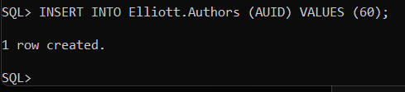

        - UserA inserting Publisher ID = 60 in Publishers
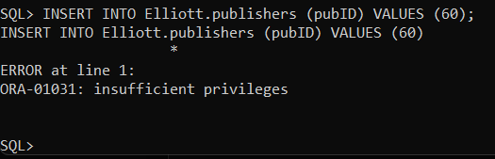

        - UserF selecting publisher ID and Title ID from Titles
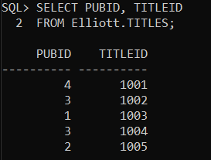

You’re done!

